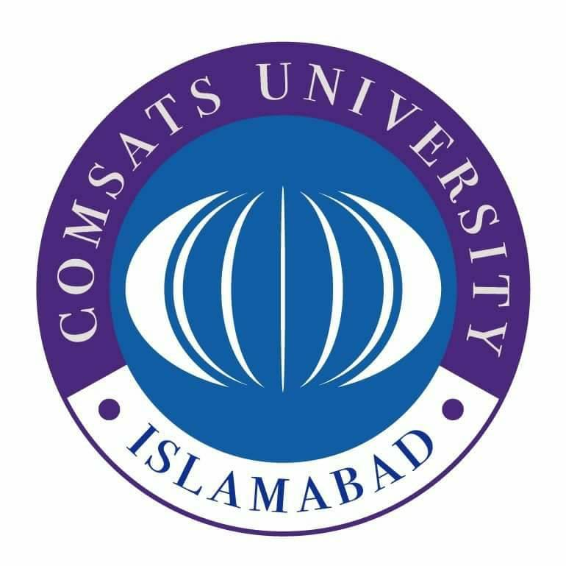

**SUBMITTED BY:** Kulsoom Khurshid

**REGISTRATION #:** SP20-BCS-044

**COURSE:** Pakistan Studies

**SUBMITTED TO:** Ma’am Tooba Aslam

**ASSIGNMENT #:** 2

**Kulsoom Khurshid**

**SP20-BCS-044**

**ASSIGNMENT # 2**

**Question 1)**

**Answer:**

Pre-Condition before 1940:

* **Bengal Pact, 1923** was an agreement signed to resolve the differences of Hindus and Muslims. Chitta Ranjan Das took the responsibility of strengthening the relations of Hindus and Muslims. He worked hard for it, but unfortunately he died in 1925 due to which this Pact was also rejected even by the people. Thus, the view of Hindu-Muslim unity quenched as the Bengal Pact failed.
* **Nehru Report, 1928** opened the Lucknow pact that came to Muslims in the past and rejected the principles of separate electorate, refused to accept all the objections that the Muslims considered important for their development and survival. It also weakened the relationship of two nations. In response to Nehru Report, **Quaid-e-Azam presented his fourteen points** for Right to Self Determination.
* **Symon Commission Report in 1930** was rejected by political parties. Three consecutive round-table conferences were held in London but no general agreement related to the reservation of seats for minor community was accepted due to which these conferences ended without any decision.
* **Act of 1935**, the British Government introduced a new constitution for the subcontinent in which the provincial autonomy was given priority. But it couldn’t get appreciation from various sectors. Both Congress and Muslim League were not satisfied with this act.
* **The General Elections 1936-1937,** in the elections of 1937 Congress won the majority. After winning, Congress tried to eradicate Muslim’s separate identity. Hindus tried to impose religious restrictions on Muslims, Muslims were not given government jobs, Urdu was replaced by Hindi in schools, the students were forced to salute the portrait of Gandhi, to put Tilak on forehead, forced to sing Bande Mataram. This attitude aroused Muslims to have a separate state.
* **1938 Meeting,** in this meeting Quaid-e-Azam declared Muslims and Hindus as two different nations.

Post Condition after 1940:

* **Cripps Mission 1942,** Sir Stafford mission was rejected by Muslim League as it has not clearly state the partition and formation of separate homeland, Congress and other parties also opposed it for their own reasons. At that time for Muslims to have a separate homeland was the major demand, which was not acceptable for the Congress.
* **Quit India Movement 1942,** Muslim League did not accept it blindly in fact, they asked to divide the land and then quit.
* **Simla Conference in 1945,** to analyze the proposal of Viceroy LordWavel, this conference was held. Five Muslim members were to be included in the Council but the Congress asked for only one Muslim representative and sent Maulana Azad as the representative of the delegation, trying to convince that they represent all the community. Quaid-e-Azam did not accept this and said that Muslim League is the only representatives of Muslims and should nominate all the 5 representatives from it. This issue cannot be resolved by the conference.
* **General election of 1945-1946,** after the failure of Simla conference, Viceroy announced elections. Quaid-e-Azam already said that they do not accept anything other than partition. The elections were organized in two categories, one the central legislative assembly and provincial elections. Congress won in 8 provinces and Muslim League achieved great success and emerges as the only representative party of Muslims by gaining all the reserved seats.
* **Cabinet Mission Plan 1946,** the British Government sent cabinet Mission to India to resolve the political restlessness in the subcontinent. This mission comprised of 3 members and had two fundamental objectives, first to determine the constitutional position and the form of government. Second was to reduce the hatred amongst the two nations so that they could live in one united India. But the elections proved this wrong. Muslim league disassociate itself from Cabinet Plan as it turn down the Muslim’s demand.
* **Direct Action Day,** on 16 August 1946, Muslim League decided to have Yaum-e-Rast Iqdam at national level because the Hindus were thinking to rule the subcontinent after the departure of British. The processions were held everywhere in which the evil designs of the congress was exposed.
* **Interim Government in 1946,** Congress was asked by the viceroy to form interim government and Muslim League was also asked to join. But the government could not run effectively due to the differences between Muslims and Hindus. Under these circumstances the Muslims demand was strengthened further. Observing all the situation, British Prime Minister decided to handover the power Indians. Thus, the establishment of Pakistan drew closer.
* **3rd June 1947,** the plan for the partition of the subcontinent was announced. The power was to be handed over to the representatives and Commission decided the boundaries of the provinces. The constitution was not applicable on the areas that are not ready to accept it. The Indian Independence Bill was passed in 1947 and India was divided into two states.
* **Radcliffe Award,** set up the Commission boundary but it was unfair to Muslims as many Muslim majority areas were given to India.

Significance of Lahore Resolution:

Following are the importance of Lahore resolution;

* It is a landmark in history of subcontinent as it decided its future.
* Muslims realize that they cannot live together with Hindus in united India.
* Jinnah identified Muslim’s as separate nation.
* The resolution acceptance strengthened the two-nation theory. Pakistan was based on Muslim nationalism.